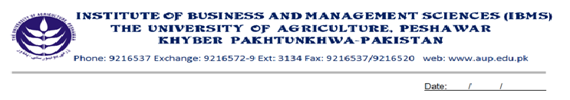

Program: BS(CS)-IV
Course Name: Linear Algebra
Course Code: MT-411
Credit Hours: 03
Course Week: 16
Total Hours: 48

Course Objectives
This course is designed for the students so that they can use techniques and concepts of linear algebra in practical problems. This course will give them complete knowledge of matrices and determinants and their application in computer related problems. They will get a complete idea of different spaces (2-space,3-space and n-space). They will also have knowledge of vector products and will be able to apply it practically.

Week-I
- Introduction to system of linear equation.

Week-2
-Solution of system of linear equation by Gaussian elimination
And Gauss Jordan Limination.
- Solution of homogeneous system of linear equations.

Week-3
- Matrices and Matrix operations.
- Transpose of Matrices.
- Invertible Matrices.
- Diagonal, triangular and symmetric Matrices.

Week-4
- Properties of inverses
- Methods to find inverse of a Matrix.

Week-5
- Introduction to Determinant.
- Finding inverse by ad joint method.

Week-6
- Cramer’s Rule for solution of system of linear equations.

Week-7
- Introduction to vectors in 2-space
- Properties of vector operation
- Dot Product of vectors

Week-8
- Angle between 2 vectors
- Cross product oft vectors
- Scalar triple product

Week-9
- Lines and planes in 3-space

Week-10
- Euclidean n-space
- Linear transformation from R to R

Week-11
- Real Vector Space

Week-12
- Subspace

Week-13
- Linear Independence Basis and Dimensions

Week-14
- Inner Product Space, Unit circle and Spheres in inner products

Week-15
- Eigen values and Eigen vectors.

Week-16
- Presentations

Total Marks: 100

Recommended Books
1. ELEMENTARY LINEAR ALGEBRA (APPLICATIONS VERSION), Howard Anton, Chris Rorres

